IEEE Malaysia Section’s Appreciation Dinner 2019
Compiled by Yew Hoong Wong & Shaw Fong Wong

On 19th Jan 2019, in conjunction of IEEE Malaysia Section’s Annual General Meeting (AGM) at Dorsett Hotel, Putrajaya, Electronics Packaging Society (EPS) Chapter has also taken its opportunity to organize its AGM in the morning session as well. After the successful AGM event in the morning, IEEE Malaysia Section has also organized an appreciation dinner in the same day at the same venue with the same full-house crowd being witnessed as well for the dinner. The event was kick-started with an opening remark by Assoc. Prof. Dr. Fawnizu A. Hussin, who is the newly elected IEEE Malaysia Section Chair for the session of 2019/2020.

There were 10 students from two universities, i.e. the University of Malaya (UM) and Universiti Teknologi Malaysia (UTM), represented EPS chapter to attend this annual appreciation dinner as well as award recognition night. During this event, IEEE EPS Chapter has been surprisingly and proudly attained two prestigious section awards, namely “2018 Outstanding Small Chapter Award” and “2nd Runner-Up Best Website Award 2018”. The awards were presented by Assoc. Prof. Dr. Mohammad Faisal Ahmad Fauzi, immediate past IEEE Malaysia Section Chair 2018/2019 and were well received by an UM student, Mr. Zhou Ding who represented EPS chapter to receive the awards. For 2018 Outstanding Small Chapter Award, a certificate and a challenge trophy were presented, whilst for 2nd Runner-Up Best Website Award 2018, a certificate and a cheque with amount of RM 100 were received.

These two highly recognized awards were a timely recognitions to EPS M’sia Chapter for our strong and persistence volunteering efforts engaged with IEEE M’sia section as well as EPS Chapters in the past years. The M’sia EPS Chapter also would like to share our appreciations to the Chapter Exco as well as to our energetic members for their strong engagement to all our technical events. In addition, the chapter would like to thanks both Dr. Shutesh Krishnan and Dr. Tan Yik Yee, who led the award nomination submission as well as the new face-lift website development projects respectively. Also not forgetting a strong support from Santa Clara Chapter, various R10 Chapters as well as BoG for their great support and encouragement to us since the formation of EPS (CPMT) M’sia Chapter back to Y2003. This has motivated the M’sia Chapter to offer more meaningful volunteering projects to shape our community with a better humanity and technical-engaged society!

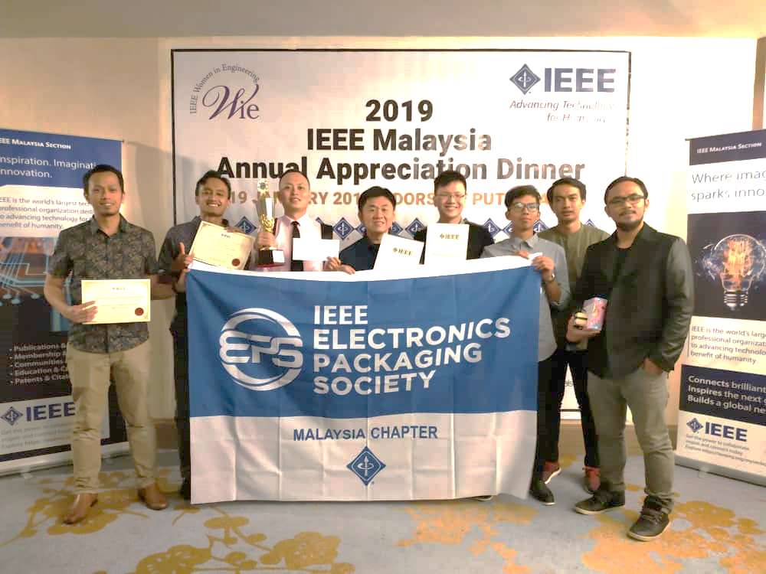
Figure: A group of happy students from UM and UTM represented IEEE EPS attended IEEE Malaysia Section Appreciation Dinner 2019.
Figure: Mr. Zhou Ding, UM’s PhD student as IEEE EPS Chapter representative received awards from Assoc. Prof. Dr. Mohammad Faisal Ahmad Fauzi, Immediate Past IEEE Malaysia Section Chair.

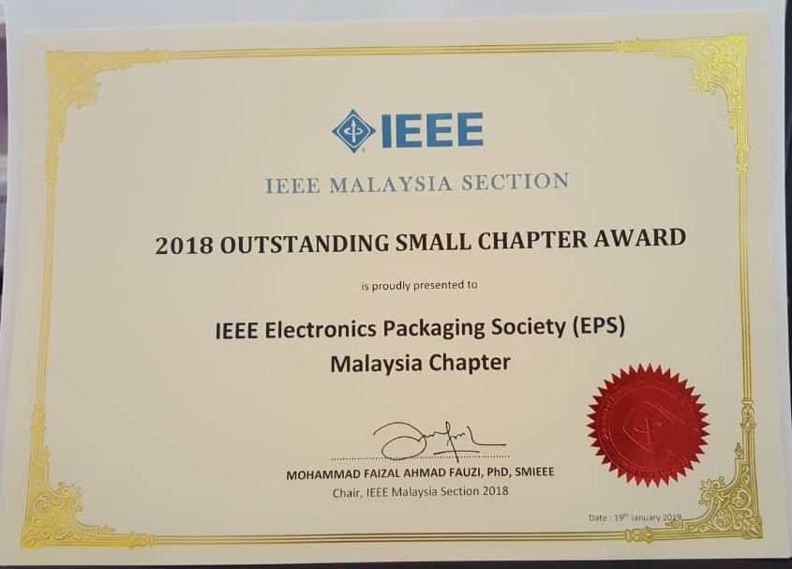
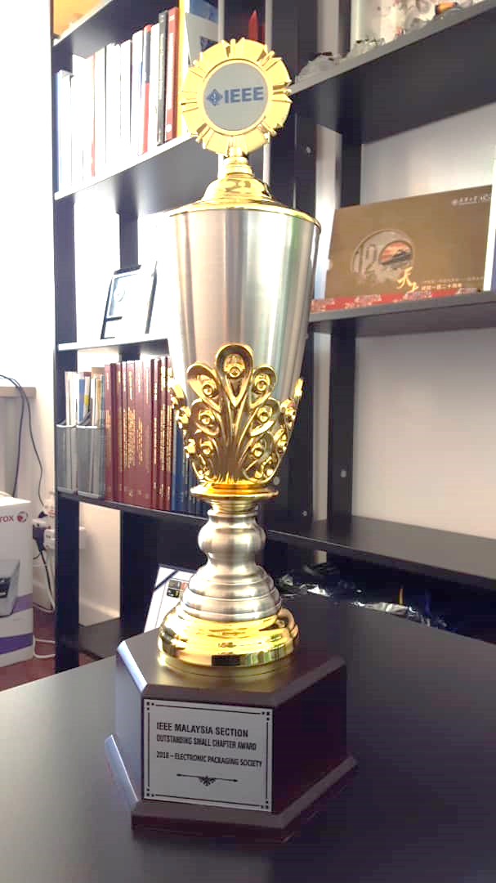

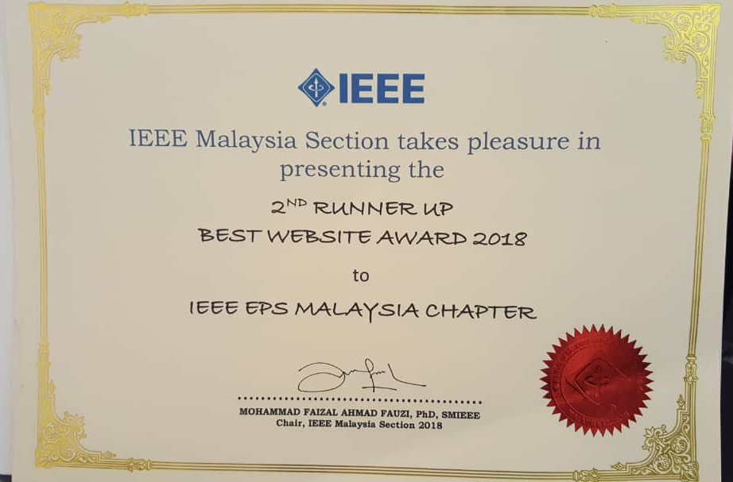

Figure: Two awards being received by IEEE EPS Chapter: a Challenge Trophy (left), a certificate of 2018 Outstanding Small Chapter Award (right top), and a certificate of 2nd Runner Up Best Website Award 2018 (right bottom).

